

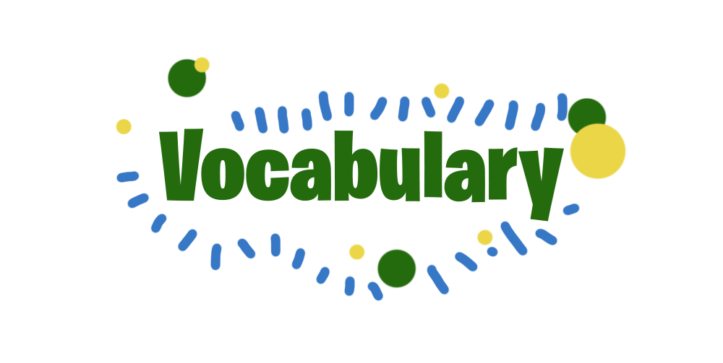



**Lesson 7**

**Forest City**

Task 1

Unscramble the words.

1. NAHSTTNAIIB
2. AYRSERKSPC
3. WLEEENRAB EGERYN OSERUCS
4. DNAISL
5. PASEARID YLITELSEF
6. ILTQUYA DATEINCOU
7. POUATILPON

